Project Development Phase
Model Performance Test
Date | 22 February 2026
Team ID | LTVIP2026TMIDS89922
Project Name | Weather-Based Prediction of Wind Turbine Energy Output
Maximum Marks | 10 Marks

Model Performance Testing:
Project team shall fill the following information in model performance testing template.
S.No. | Parameter | Values | Screenshot
1 | Regression Model Metrics | R² Score = 0.91 | 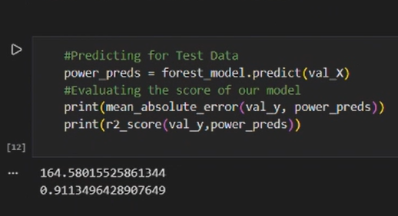
2 | Regression Model Metrics | MAE = 164.5

Model | R² Score
Linear Regression | 0.83
Decision Tree Regressor | 0.88
Random Forest Regressor | 0.91

